**PATUAKHALI SCIENCE AND TECHNOLOGY UNIVERSITY**

**cOURSE CODE 112**

**SUBMITTED TO:**

Prof. MD Mahbubur Rahman Sir

**Department of Computer Science And Communication**

**Engineering**

**Faculty of Computer Science And Engineering**

**SUBMITTED BY:**

Name: MD Noushad Bhuiyan

ID: 2102038, Registration No: 10165

Faculty of Computer Science and Engineering

**Date of submission: 31-3-2023**

**Programming Exercise**

**6.1 Even or Odd**

#include<stdio.h>

int main()

{ int num;

printf("Enter an integer: ");

scanf("%d",&num);

if(num%2==0)

printf("Even");

else if(num!=0)

printf("odd");

else

printf("the number is 0");

return 0;

}

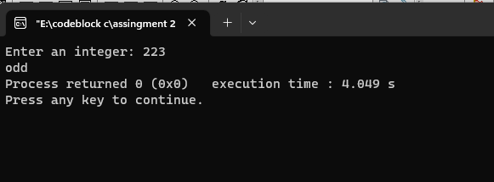

**6.2 sum of all integers greater than 100 and less than 200 that are divisible by 7.**

#include<stdio.h>

int main()

{

int sum=0,n=200,i;

for(i=101;i<n;i++)

{

if(i%7==0)

{

sum=sum+i;

}

}

printf("The sum is: %d",sum);

}

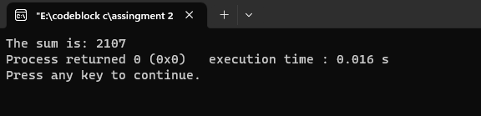

**6.3 two linear equations with two unknowns x1 and x2**

#include<stdio.h>

int main()

{

float a,b,c,d,m,n,x1,x2;

printf("Enter a: \n");

scanf("%f",&a);

printf("Enter b: \n");

scanf("%f",&b);

printf("Enter c: \n");

scanf("%f",&c);

printf("Enter d: \n");

scanf("%f",&d);

printf("Enter m: \n");

scanf("%f",&m);

printf("Enter n: \n");

scanf("%f",&n);

x1=((m*d-b*n)/(a*d-c*b));

x2=((n*a-m*c)/(a*d-c*b));

printf("The value of x1 is : %0.2f\n",x1);

printf("The value of x2 is : %0.2f\n",x2);

}

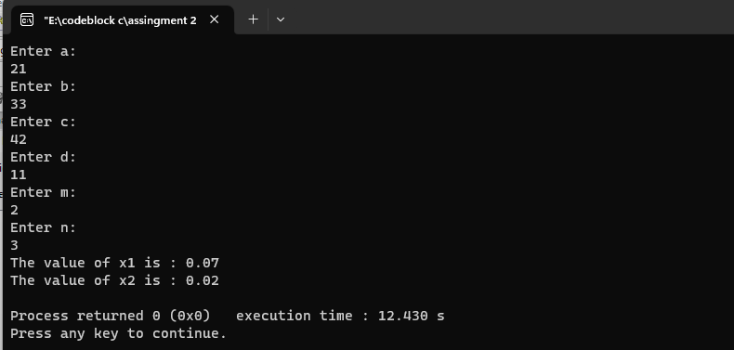

**6.4 Admission to a professional course is subject**

#include<stdio.h>

int main()

{

int m,p,c,s,mp;

printf("Requirement:\n");

printf("Mark in mathematics: 60\nMark in Physics: 50\nMark in Chemistry: 40\nTotal number in all three subject: 200+\nOr Total marks in Math and Physics:150 \n");

printf("Enter your Mathematics number: ");

scanf("%d",&m);

printf("Enter your Physics number: ");

scanf("%d",&p);

printf("Enter your Chemistry number: ");

scanf("%d",&c);

s=p+c+m;

mp=m+p;

if(m>=60 && p>=50 && c>=40)

{

if(s>=200 || mp>=150)

{

printf("You are eligible candidate");

}

}

else

printf("Not eligible");

}

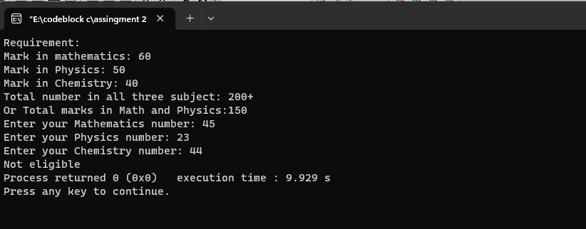

**6.7 Pattern**

#include<stdio.h>

int main()

{

int n,r,c;

printf("Enter raw number: ");

scanf("%d",&n);

for(r=1;r<=n;r++)

{

for(c=1;c<=r;c++)

{

printf("%d ",c);

}

printf("\n");

}

printf("\n");

for(r=1;r<=n;r++)

{

for(c=1;c<=r;c++)

{

printf("%d ",c%2);

}

printf("\n");

}

}

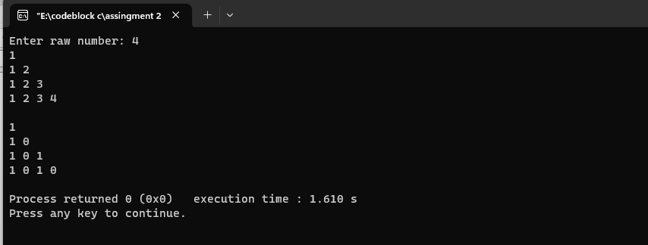

**6.8 seasonal discounts on purchase of items**

#include<stdio.h>

int main()

{

float ch,p;

int n;

printf("Discount on a purchase of items\n");

printf("1. Purchase amount: 0 - 100\n2. Purchase amount: 101 - 200\n3. Purchase amount: 201 -300\n4. Purchase amount: 300 or above\n");

printf("Enter Your Purchase ammount: \n");

scanf("%f",&ch);

if(ch>=0 && ch<=100)

{

p=ch-ch*0.05;

}

else if(ch>=101 && ch<=200)

{

p=ch-ch*0.125;

}

else if(ch>=201 && ch<=300)

{

p=(ch-(ch*0.175));

}

else if(ch>=301)

{

p=(ch-(ch*0.25));

}

printf("The net amount to be paid by the customer: %0.2f",p);

}

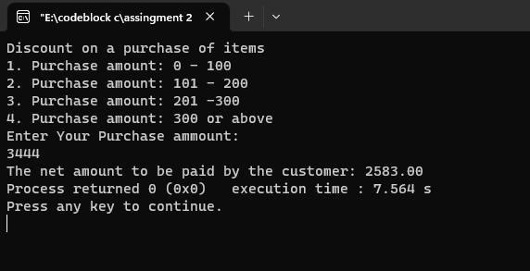

**6.10 compute the real roots of a quadratic equation**

#include<stdio.h>

int main()

{

float a,b,c,n1,n2,D;

printf("Enter a: ");

scanf("%f",&a);

printf("Enter b: ");

scanf("%f",&b);

printf("Enter c: ");

scanf("%f",&c);

D= sqrt(b*b-4*a*c);

x1=(-b-D)/(2*a);

x2=(-b+D)/(2*a);

printf("The value of x1: %f",x1);

printf("The value of x2: %f",x2);

}

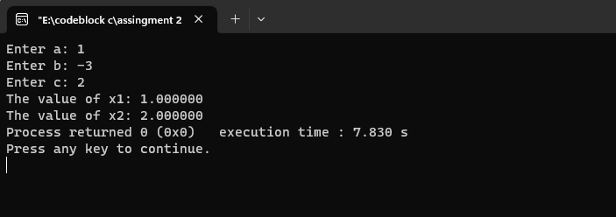

**6.11 displays the output stating that they are the sides of right-angled triangle**

#include<stdio.h>

int main()

{

int n1,n2,n3;

printf("Enter first value of a triangle:\n");

scanf("%d",&n1);

printf("Enter second value of a triangle:\n");

scanf("%d",&n2);

printf("Enter third value of a triangle:\n");

scanf("%d",&n3);

printf("\nThe right-angled triangles are : %d\t %d\t %d\t",n1,n2,n3);

}

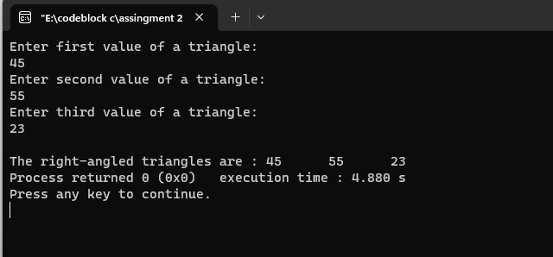

**6.12 An electricity board charges**

#include<stdio.h>

int main()

{

float unit,sum=100;

printf("Enter Electricity in unit : ");

scanf("%f",&unit);

if(unit<=200)

sum=sum+unit*0.8;

else if(unit>200&&unit<=300)

sum=sum+unit*0.9;

else if(unit>300)

sum=sum+unit*1;

printf("The total charge is : %0.2f Taka",sum);

}

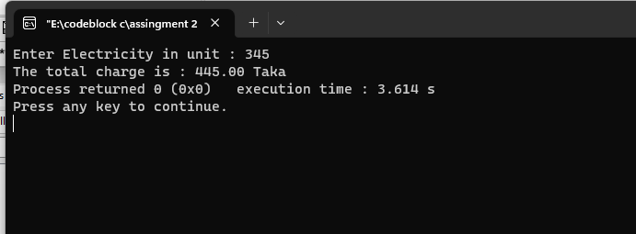

**6.13 compute and display the sum of all integers that are divisible by 6 but not divisible by 4 and lie between 0 and 100**

#include<stdio.h>

int main()

{

int sum=0,i,n;

n=100;

for(i=0;i<=n;i++)

{

if(i%6==0&&i%4!=0)

sum= sum+i;

}

printf("The sum of the number \ndivisible by 6 but not divisible \nby 4 and between 0 to 100 is = %d",sum);

}

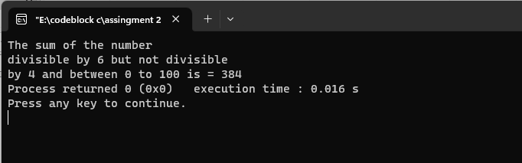

**6.14 the number is a prime number and display the output accordingly.**

#include<stdio.h>

int main()

{

int n,i,count=0;

printf("Enter a number: ");

scanf("%d",&n);

for(i=2;i<n;i++)

{

if(n%i==0){

count++;

break;}

}

if(count==0)

{

printf("This is a Prime Number");

}

else

{

printf("This is not a Prime Number");

}

return 0;

}

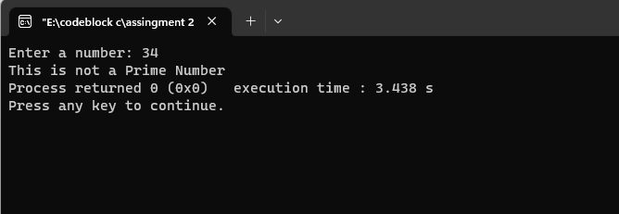

**6.15 double-type value x that represents angle in radians**

#include<stdio.h>

#include<math.h>

int main()

{

double n,x,r;

char T;

printf("Enter Angle value: ");

scanf("%lf",&x);

r=x*(180/3.1416);

printf("Enter A character from S/C/T \n");

scanf("%s",&T);

switch(T){

case 's':

case 'S':

n=sin(r);

case 'c':

case 'C':

n=cos(r);

case 't':

case 'T':

n=tan(r);

}

printf("%lf",n);

}

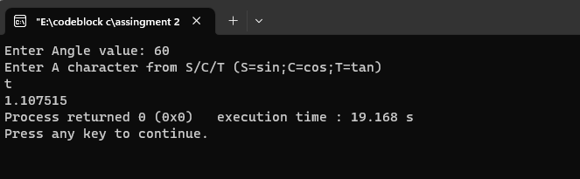

**6.16 Enumaration**

#include<stdio.h>

enum days_in_week{

monday=1,tuesday,wednesday,thursday,friday,saturday,sunday

};

int main()

{

enum days_in_week day1

day1=wednesday;

printf("Wednesday = %d");

}

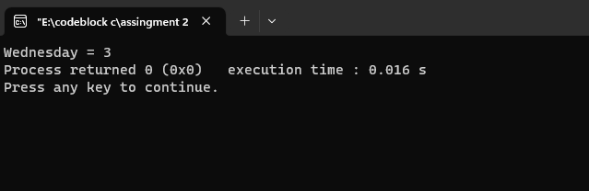

**6.17 Greater or smaller or equal**

#include<stdio.h>

int main()

{

int a,b;

printf("Enter Two integer(a,b): ");

scanf("%d %d",&a,&b);

if(a>b)

printf("a is greater than b");

else if(a<b)

printf("b is greater than a");

else

printf("a and b are equal");

}

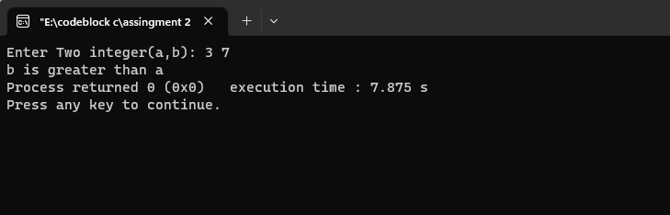

**6.18 Mark distribution with Grading system**

#include<stdio.h>

int main()

{

int n;

printf("Enter your total marks percentage: ");

scanf("%d",&n);

if(n>=80)

printf("First Division");

else if(n>=60 && n<80)

printf("Second Division");

else if(n<60)

printf("Third Division");

}

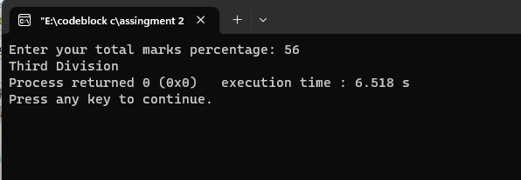

**6.19 display the corresponding number of days in that month**

#include<stdio.h>

int main()

{

int n;

printf("The 12 months are\n1.January\n2.February\n3.March\n4.April\n5.May\n6.June\n7.July\n8.August\n9.September\n10.October\n11.November\n12.December");

printf("\nChoose month number: ");

scanf("%d",&n);

switch(n)

{

case 1:

printf("January = 31 days");

case 2:

printf("February = 28 days");

case 3:

printf("March = 31 days");

case 4:

printf("April = 30 days");

case 5:

printf("May = 31 days");

case 6:

printf("June = 30 days");

case 7:

printf("July = 31 days");

case 8:

printf("August = 31 days");

case 9:

printf("September = 30 days");

case 10:

printf("October = 31 days");

case 11:

printf("November = 30 days");

case 12:

printf("December = 31 days");

}

}

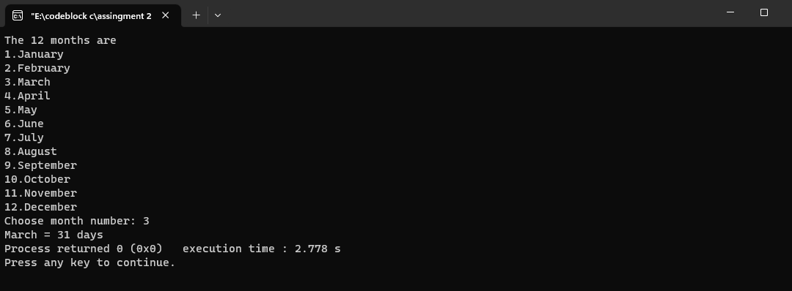

[C Program to Check Whether a Character is a Vowel or Consonant](https://www.programiz.com/c-programming/examples/vowel-consonant)

#include<stdio.h>

int main()

{

char ch;

printf("enter a letter:");

scanf("%c",&ch);

if(ch=='a'||ch=='e'||ch=='i'||ch=='o'||ch=='u')

printf("this is a vowel");

else

printf("this is a consonent");

return 0;

}

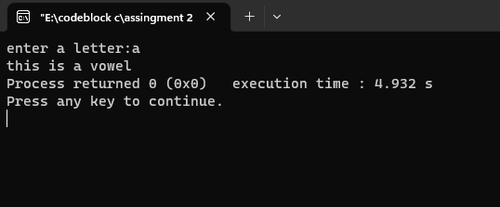

[C Program to Check Leap Year](https://www.programiz.com/c-programming/examples/leap-year)

#include<stdio.h>

int main()

{

int n;

//n=year

printf("Enter The year: ");

scanf("%d",&n);

if(n%4==0)

{

if(n%100==0)

{

if(n%400==0)

{

printf("The year is a leap year");

}}}

else

printf("The year is not leap year");

}

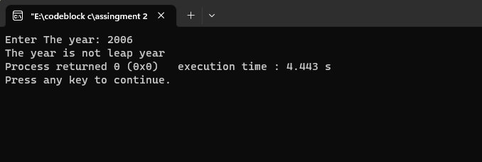

[C Program to Check Whether a Number is Positive or Negative](https://www.programiz.com/c-programming/examples/negative-positive-zero)

#include<stdio.h>

int main()

{

int n;

printf("Enter the number: ");

scanf("%d",&n);

if(n>0)

{

printf("The number is positive ");

}

else if(n<0)

{

printf("The number is Negative ");

}

else

{

printf("The number is Zero");

}

}

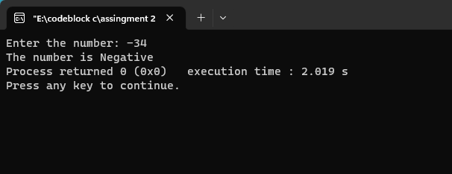

[C Program to Check Whether a Character is an Alphabet or not](https://www.programiz.com/c-programming/examples/alphabet)

#include<stdio.h>

int main()

{

char n;

printf("enter the character: ");

scanf("%c",&n);

if(n>=65 && 90>=n)

printf("This is a alphabetic character");

else if(n>=97 && 122>=n)

printf("This is a alphabetic character");

else

printf("This is not a alphabetic character");

}

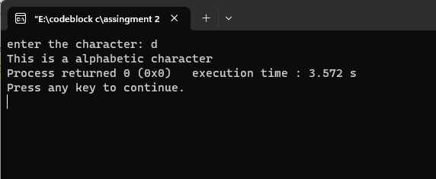

[C Program to Calculate the Sum of Natural Numbers](https://www.programiz.com/c-programming/examples/sum-natural-numbers)

#include<stdio.h>

int main()

{

int n,i,sum=0;

printf("Enter the value of n\n");

scanf("%d",&n);

for(i=1;i<=n;i++)

{

sum=sum+i;

}

printf("The sum of 1 to %d all natural number is %d",n,sum);

}

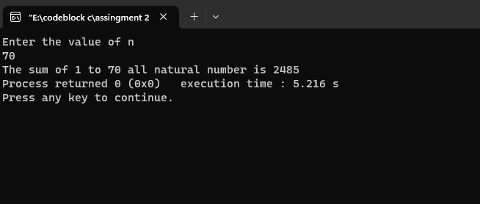

[C Program to Factorial of a Number](https://www.programiz.com/c-programming/examples/factorial)

#include<stdio.h>

int main()

{

int n,i,fact=1;

printf("Enter any positive number: ");

scanf("%d",&n);

for(i=1;i<=n;i++)

{

fact=fact*i;

}

printf("factorial of %d is = %d",n,fact);

}

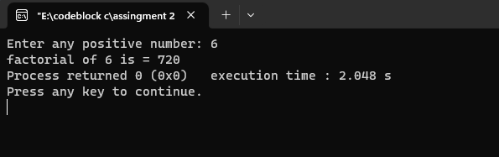

[C Program to Generate Multiplication Table](https://www.programiz.com/c-programming/examples/multiplication-table)

#include<stdio.h>

int main()

{

int n,i;

printf("Enter number: ");

scanf("%d",&n);

for(i=1;i<=10;i++)

{

printf("%d * %d = %d",n,i,n*i);

printf("\n");

}

}

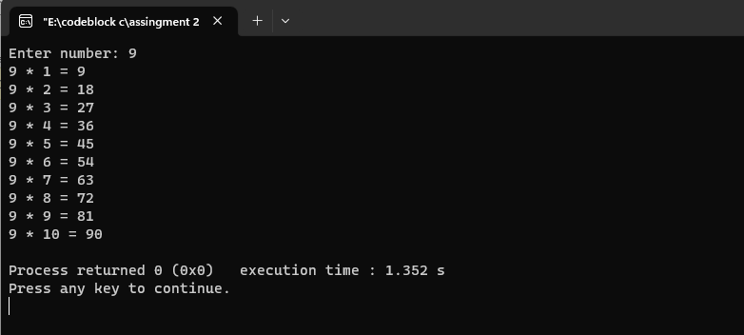

[C Program to Display Fibonacci Sequence](https://www.programiz.com/c-programming/examples/fibonacci-series)

#include<stdio.h>

int main()

{ //fibonacci number

int n,i,num1=0,num2=1,fib;

printf("Enter n: ");

scanf("%d",&n);

printf("%d\n",num1);

printf("%d\n",num2);

for(i=0;i<=n-3;i++)

{

fib=num1+num2;

num1=num2;

num2=fib;

printf("%d\n",fib);

}

}

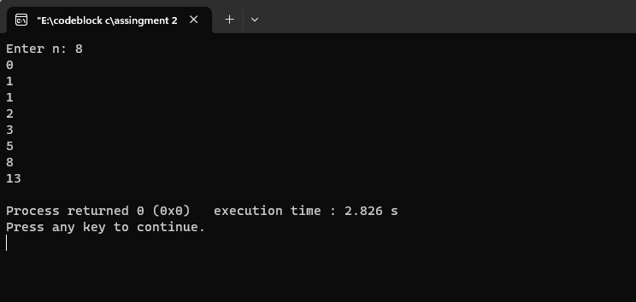

[C Program to Find GCD of two Numbers](https://www.programiz.com/c-programming/examples/hcf-gcd)

#include<stdio.h>

int main()

{

int n1,n2,rem,lcm,gcd,num1,num2;

printf("Enter 1st number: ");

scanf("%d",&num1);

printf("Enter 2nd number: ");

scanf("%d",&num2);

n1=num1;

n2=num2;

while(n2!=0)

{

rem=n1%n2;

n1=n2;

n2=rem; }

gcd=n1;

printf("GCD is %d\n",gcd);

}

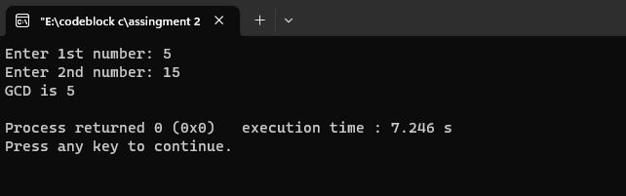

[C Program to Find LCM of two Numbers](https://www.programiz.com/c-programming/examples/lcm)

#include<stdio.h>

int main()

{

int n1,n2,rem,lcm,gcd,num1,num2;

printf("Enter 1st number: ");

scanf("%d",&num1);

printf("Enter 2nd number: ");

scanf("%d",&num2);

n1=num1;

n2=num2;

while(n2!=0)

{

rem=n1%n2;

n1=n2;

n2=rem; }

gcd=n1;

lcm=((num1*num2)/gcd);

printf("LCM is %d\n",lcm);

}

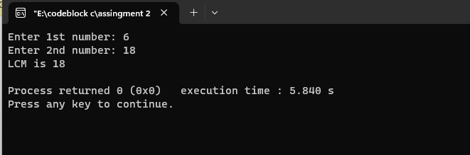

[C Program to Display Characters from A to Z Using Loop](https://www.programiz.com/c-programming/examples/display-alphabets)

#include<stdio.h>

int main()

{

int i,n;

char c;

n=90;

printf("All alphabetic from A to Z are: \n");

for(i=65;i<=n;i++)

{

printf("%c\n",i);

}

}

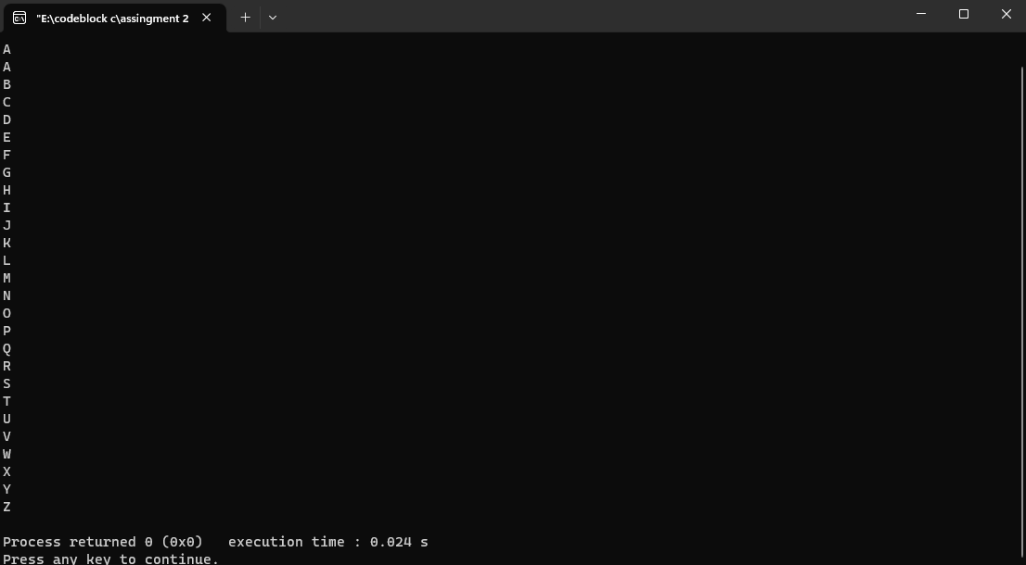

[C Program to Count Number of Digits in an Integer](https://www.programiz.com/c-programming/examples/digits-count)

#include<stdio.h>

int main()

{

int n,count=0;

printf("Enter A value:");

scanf("%d",&n);

while(n!=0)

{

n=n/10;

count++;

}

printf("The number of digits are: %d",count);

}

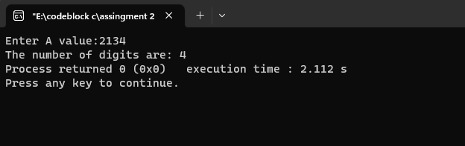

[C Program to Reverse a Number](https://www.programiz.com/c-programming/examples/reverse-number)

#include<stdio.h>

int main()

{

int n,count=0;

printf("Enter A value:");

scanf("%d",&n);

while(n!=0)

{

n=n/10;

count++;

}

printf("The number of digits are: %d",count);

}

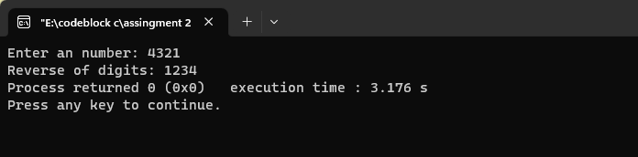

[C Program to Calculate the Power of a Number](https://www.programiz.com/c-programming/examples/power-number)

#include<stdio.h>

int main()

{ //x=number;y=power

double x,y,result;

printf("Enter number: ");

scanf("%lf",&x);

printf("Enter power value: ");

scanf("%lf",&y);

result=pow(x,y);

printf("Result is: %0.2lf",result);

return 0;

}

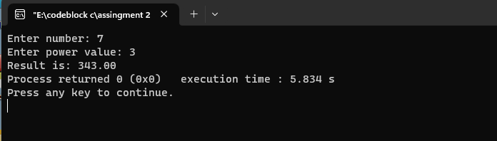

[C Program to Check Whether a Number is Palindrome or Not](https://www.programiz.com/c-programming/examples/palindrome-number)

#include<stdio.h>

int main()

{

int n,num,r,sum=0;

printf("Enter a number: ");

scanf("%d",&num);

n=num;

while(n!=0)

{

r=n%10;

sum=sum*10+r;

n=n/10;

}

if(sum==num)

printf("This is a Palindrome number");

else

printf("Not a palimdrome number");

return 0;

}

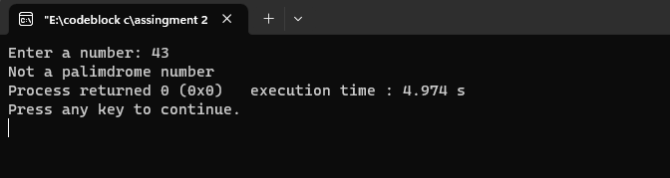

[C Program to Check Armstrong Number](https://www.programiz.com/c-programming/examples/check-armstrong-number)

#include<stdio.h>

int main()

{

int n,num,temp=0,r;

printf("Enter a number: ");

scanf("%d",&n);

num=n;

while(num!=0)

{

r=num%10;

temp=temp+(r*r*r);

num=num/10;

}

if(temp==n)

printf("The number is a armstrong number");

else

printf("Not a armstrong number");

return 0;

}

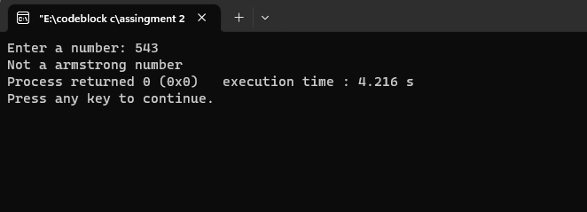

[C Program to Make a Simple Calculator Using switch...case](https://www.programiz.com/c-programming/examples/calculator-switch-case)

#include<stdio.h>

int main()

{

float sum,sub,mul,div;

int a,b,n;

printf("Main menu:\n1.SUM\n2.SUB\n3.MUlTIPLICATION\n4.DIVISION\nEnter your choice: ");

scanf("%d",&n);

switch(n)

{

case 1:

{printf("Enter 1st value:");

scanf("%d",&a);

printf("Enter 1st value:");

scanf("%d",&b);

sum=a+b;

printf("Sum is: %0.2f",sum);}

break;

case 2:

{printf("Enter 1st value:");

scanf("%d",&a);

printf("Enter 1st value:");

scanf("%d",&b);

sub=a-b;

printf("Sub is: %0.2f",sub);}

break;

case 3:

{printf("Enter 1st value:");

scanf("%d",&a);

printf("Enter 1st value:");

scanf("%d",&b);

mul=a*b;

printf("Multiplication is: %0.2f",mul);}

break;

case 4:

{printf("Enter 1st value:");

scanf("%d",&a);

printf("Enter 1st value:");

scanf("%d",&b);

div=a/b;

printf("Division is: %0.2f",div);}

break;

}

}

